Jerry Clay Academy
Pupil Premium Spending
2020-21
2020-21
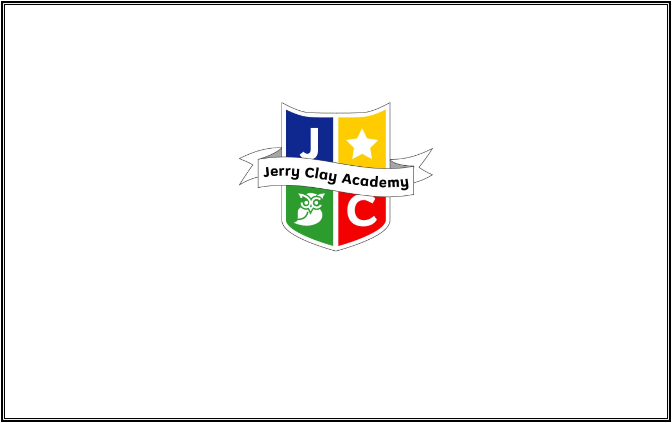

1. Key Objective: To improve outcomes for all Pupil Premium (PP) students to bring attainment in line with expected levels of progress in
every year group
Action: Deployment of LSA
LSA contracted to work to support intervention and employed to remove barriers to learning, engage parents and enhance academic progress, working with
students who are below national expectation of attainment for Eng/Ma.
KS2 staff trained in Catch up Maths training (1 Teaching Assistant)
Rational : Sutton document ‘One-to-one tutoring+5 months moderate impact’
‘For pupils eligible for free school meals (FSM) with lower prior attainment, those who received tuition were more likely to achieve expected at KS2 than those who
did not receive tuition.’
Success Criteria : A reduction in the attainment gap of PP and non PP students in every year group from Sept 2019 – June 2020 in mathematics and English
Dates
Sept 2020
Person responsible
TP
Monitoring and Evaluation
Tracking and monitoring data of PP cohort via data collection, student
Cost
feedback, exit data, Lesson obs schedule of intervention lessons as part of
PM.
£2000
2020-21
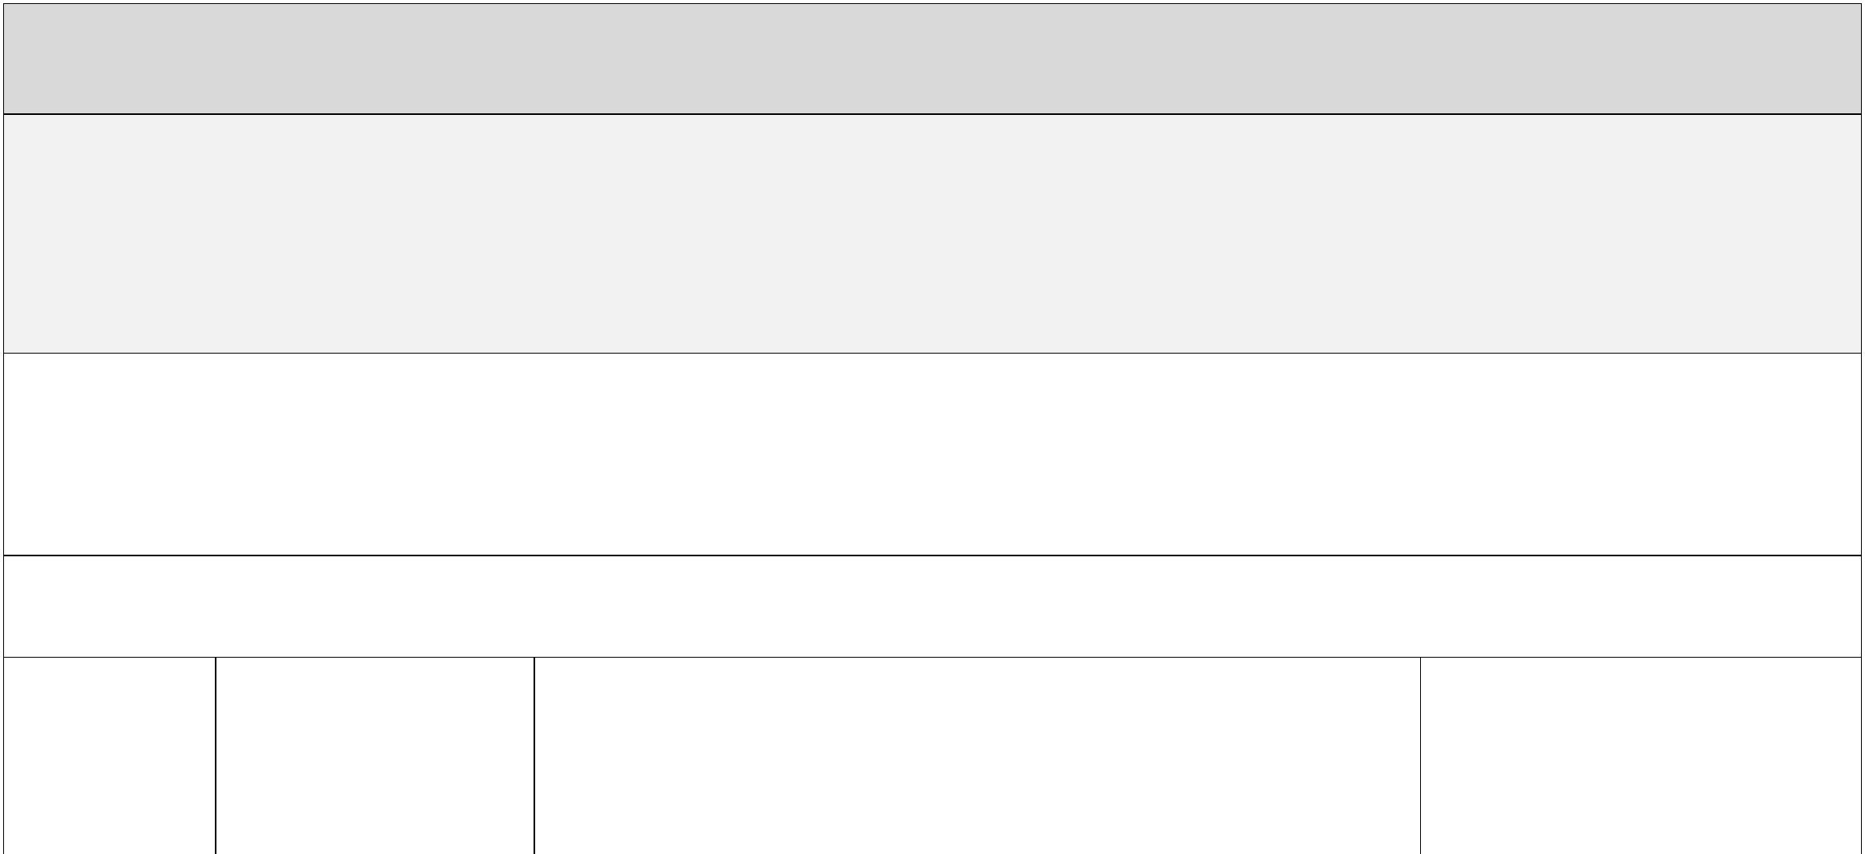

2. Key Objective: Further develop Phonics (RWI) support for 1:1 & Reading 1:1 daily
Action: RWI 1:1 support All students whose attainment falls below the national expectations for reading and particularly phonics are to be supported through
Phonics 1:1 support & daily reading
Rational: Sutton document stresses that improving literacy improves student outcomes overall.
Thereby reducing the attainment variation between PP and non PP.
Success Criteria: Pupils are enabled to gain at least the threshold score for the Phonics screening test & a Reading age in line with their age
Dates
Starting Sept 2020
Person responsible
LSA – MW, TP - RWI Leader
Monitoring and Evaluation
RWI assessments
Cost
£5000
Outcomes
3. Key Objective: To improve curriculum engagement and academic achievement
Action: Implement an academic subsidy to enable PP students to fully access the curriculum and reduce attainment gap.
Rational: Sutton document ‘the choices that schools make in allocating the money will be vital so that the funding can help raise pupils’ attainment and
aspirations.’
Success Criteria: Attainment gap between PP and non PP reduces. PP students make progress in line with expectations.
2020-21
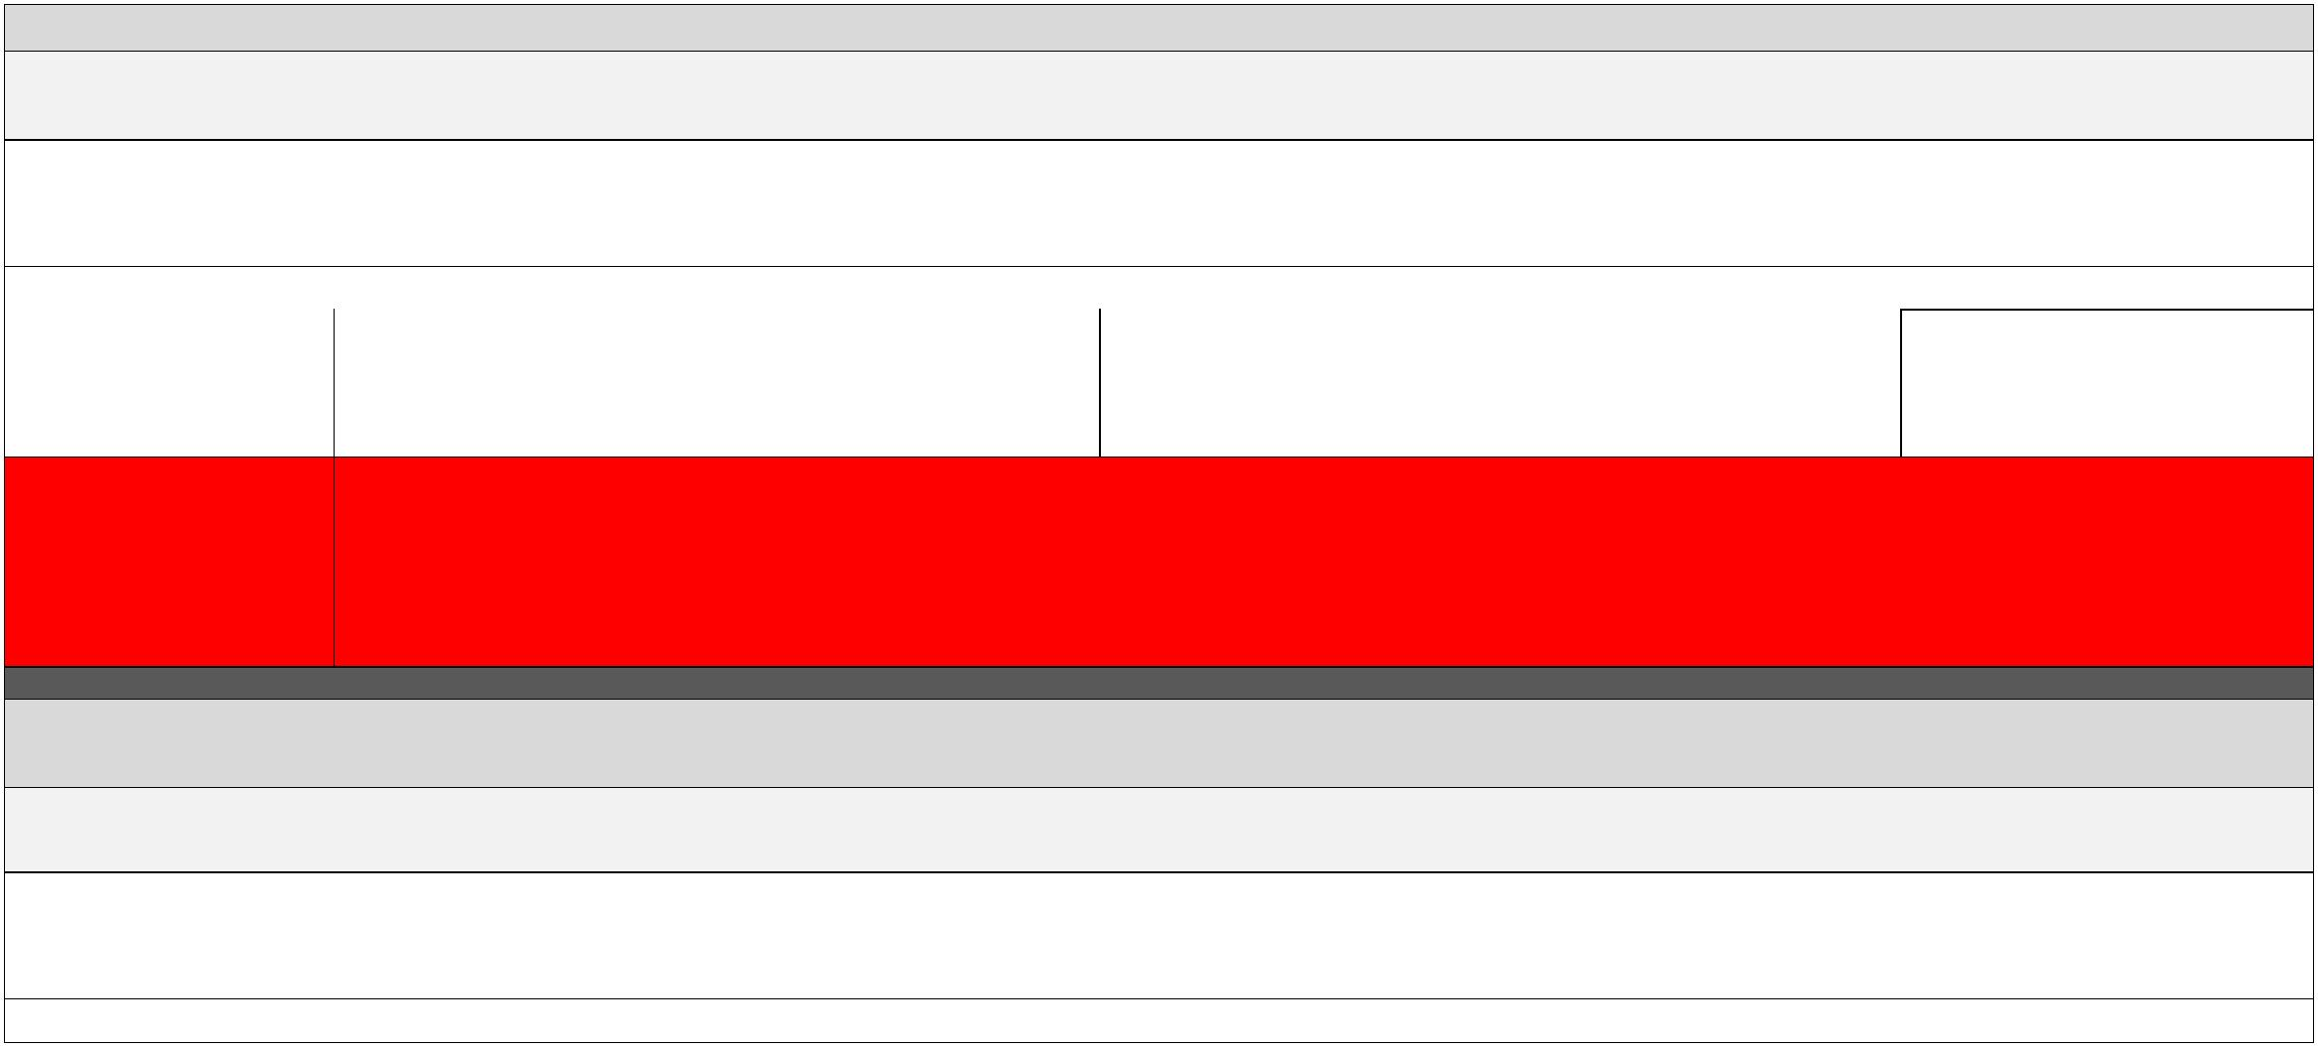

Dates
From Sept 2020
Person responsible
TS
Monitoring and Evaluation
Cost
£1123
Progress of students provided with support to be
monitored to ensure value for money. I&O termly
review.

2020-21

Action: Implement an engagement subsidy to enable PP students to fully access the extra-curricular and financially dependent curriculum activities and reduce
attainment gap, support those students who do not have breakfast and support students with after school activities.
Rational: National College Research cites effective embedded reward policies as being a contributory factor to improving attainment and engagemen
Success Criteria: E6 cohort attendance of extracurricular and extended curriculum activities not inhibited by financial constraints
Dates
Sept 2020
Person responsible
TS
Monitoring and Evaluation
PP attendance of extended curriculum and activities
day support.
Cost
£1377
Ensure breakfast and after school provision is available
for any PP in need to ensure an effective start to the
school day
Support PP students in peripatetic lessons
Supplement school trips and any enhancement activity
Outcomes:
Action: PP/ CLIC students’ entitlement is met.
PP identified cohort – monitor attainment and offer specific academic and emotional support as appropriate.
Rational: PEP reports must show how the PP has been spent on supporting the individual students in public care.
Success Criteria: CLIC make academic and social progress in line with peers.
Dates
Sept 2020
Person responsible
Monitoring and Evaluation
Cost
Progress of students to be monitored to ensure value
for money. Evaluation of spend via ½ termly PEP
report.
TP
£1000
Action: LSA – support for LSA to ensure effective support in and out of the classroom
Rational: To ensure CLIC child has 1:1 pastoral designated time every day support, either in or out of the classroom
Success Criteria : SEND/PP student outcomes in line with expected levels of progress in Eng/ma, positive value added scores at KS2.
2020-21

Dates
Sept onwards.
Person responsible
SENDCO/line manager
Monitoring and Evaluation
Impact forms
Cost
Monitoring file for Learning Mentor – monitored by
the SENDCo
4. Key Objective: Attendance: to implement strategies addressing the attendance gap between for PP and CLA and non PP students
Action: Utilise Learning Support Assistant to engage with parents of PP Students in ensuring student attendance is high.
Rational: EEF ‘the choices that schools make in allocating the money will be vital so that the funding can help raise pupils’ attainment and aspirations.’
Success Criteria: Attendance gap between PP and non PP continues to reduce.
Dates
Sept 2020 onwards.
Person responsible
TS & MW
Monitoring and Evaluation
Tracking and monitoring of progress in Eng/ma of
Cost
£1000
students receiving academic 1:1.
Outcomes:
1. Key Objective: Social & emotional support: to improve confidence and self-esteem outcomes for PP* students to bring attainment in line with expected levels
of progress aswell as a self-belief that they can achieve beyond their expectations
Action: Implement a team building session and mentoring system to improve self-confidence and self-esteem. Give 1:1 nurture support to individuals where
needed.
Rational: Sutton document ‘the choices that schools make in allocating the money will be vital so that the funding can help raise pupils’ attainment and
aspirations.’
2020-21

Success Criteria: Attainment gap between PP and non PP reduces. PP students make progress in line with expectations because their social and emotional
development is supported
Dates
From Sept 2020
Person responsible
Intervention LSA, TP, TS
Monitoring and Evaluation
Progress of students provided with support to be
monitored to ensure value for money.
-Rigorous tracking in relation to progress and
outcomes
Action: Intervention LSA– Training for appointed LSA and identified TAs to ensure that skills needed for the removing barriers to academic success are up to date.
Rational: To equip LSA and identified TAs with skills necessary to aid in addressing academic barriers to learning and develop students skills up to Year 6.
Success Criteria : Student outcomes in line with expected levels of progress in Eng/ma, positive value added scores at KS2.
LSA and identified TAs attend training.
Dates
Sept 2020 onwards.
Person responsible
SENCO/ HT
Monitoring and Evaluation
Tracking and monitoring of progress in Eng/ma of
students receiving LSA support.
Cost
£266
Action: LSA – support for LSA to ensure effective support in the classroom
Rational: To equip intervention LSA with a laptop and appropriate resources to support the skills necessary to aid in addressing academic barriers to learning.
Success Criteria : SEND/PP student outcomes in line with expected levels of progress in Eng/ma, positive value added at KS1 & 2.
2020-21

Dates
Sept onwards.
Person responsible
SENDCO, EHT
Monitoring and Evaluation
Impact forms
Cost
£7165
Lesson obs
Pastoral meeting minutes
Key objective: Provide breakfast and after school clubs, including access to a variety of clubs as part of the academy’s wider provision.
Action: Ensure PP children have access to a wide variety of after school experiences & a nutritional breakfast.
Dates
Sept onwards
Person responsible
SENDCo, EHT to check provision is accessed
Monitoring and Evaluation
Registers
Cost
Club analysis and evaluation of impact
£11,409
Total proposed spend 2020/2021
£30.340
Actual total spend - £30,340
2020-21

2020-21

