3rd April 2020
Good morning everyone

Hope you are all doing well and staying safe. It has been fantastic to see all home learning that has been going on in lots of different ways - and great to see so many more of you sharing this on Twitter!

As it would normally be our ‘Easter break’ over the next fortnight, I will not send a Learning Plan during this time. We believe that is important that the children do have some ‘rest’ time, just as they would do under normal circumstances - as each one of them has worked so hard this year.
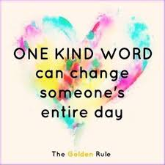
However, as with any other break we would expect that Y6 continue to read daily. They can also still access Spelling Shed, Times Table Rock Stars and Manga High should they wish to use these to practise skills. If you choose to do a little bit of written work there are also the Easter Maths packs to practise arithmetic skills.

I have attached some Easter puzzles/colouring if you think this is something you would like to use. If not, that is absolutely fine! I have also attached some activity ideas and apps, which don’t require any printing. There is no expectation that you do any of these – they are simply ideas for you to use as you wish

There is also a JCA Easter Egg Decorating Competition. The competition is to decorate a hard-boiled egg (be as creative as you can!) We will tweet some examples as the week goes on!
The winning prize will be a £10 Amazon digital voucher for a winner in every class!

Kind regards,
Miss Karlsson

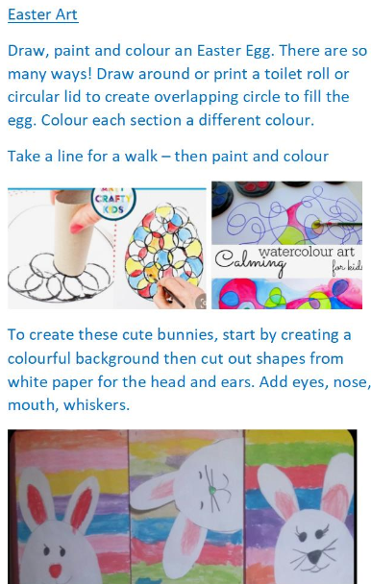
Easter activities

Create Easter Cards

Create your own Easter masks (using paper plates)

Set up your own egg and spoon race (tip: use a ball rather than an egg!)

Create a model using straws/lego/ play dough anything you have!

There are many craft activities here
https://www.easypeasyandfun.com/15-must-do-easter-crafts-and-activities-for-kids/

https://www.architectureartdesigns.com/15-fun-easter-crafts-to-keep-the-kids-busy-during-lockdown/

Easter origami - https://www.origami-resource-center.com/easter-origami.html

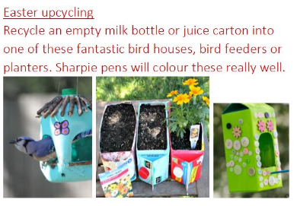
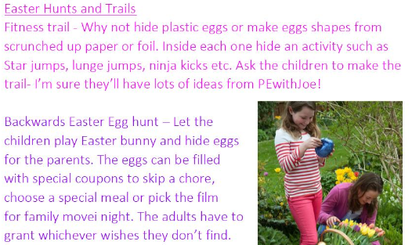

BBC Food also have some fun and easy Easter recipes to try!

https://www.bbcgoodfood.com/recipes/collection/easter-kids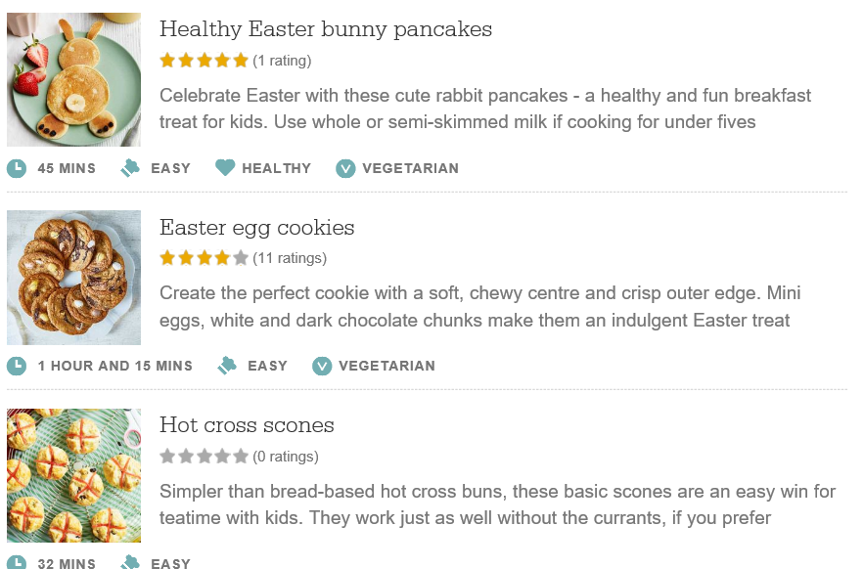

Apps and online resources

Hidden Egg Hunt
Easter Egg Painting Games
Easter Egg colour By Number

Reading

https://www.storylineonline.net/

12-12.45pm R.J. Palacio reading Wonder each day from Wednesday 25th March twitter.com/rjpalacio

Story time with David Walliams everyday 11am www.worldofdavidwalliams.com

https://home.oxfordowl.co.uk/books/free-ebooks/

https://classroommagazines.scholastic.com/support/learnathome/grades-6-12.html

Art
http://www.robbiddulph.com/draw-with-rob

