**Jerry Clay Academy**

**Year 1**



**Easter Activities**

|  |  |  |
| --- | --- | --- |
| **Easter colouring**  In the pack is different Easter inspired colouring pictures for you to colour in. | **Science challenges**  Have a look at the science challenges in the pack and have a go at them. | **Make Playdough**  Use the recipe in the pack to create playdough. Can you create a story about Easter using it |
| **Baking**  Make some Easter cupcakes or cornflake cakes. Look in the pack for some inspiration for what they can look like. | **Papier Mache**  Can you turn your Easter egg design into a papier mache egg? Use the instructions in the pack to create it. | **Alphabet challenge**  In and around the house try and find an object that starts with every letter of the alphabet, can you write them down or collect them. |
| **Create an obstacle course**  Can you create an obstacle course around the house or in the garden that you have to try and complete? | **Build a den**  Can you create a den to play inside or sit inside to watch a film. Get creative, can you make decorations for your den? | **Poetry**  Can you create an acrostic poem about Easter and Spring? Look at mine for some ideas |

**These are optional activities to keep you entertained over the holidays, have fun!**

**Easter colouring**

Science Challenges

Playdough Recipe

Easter Baking

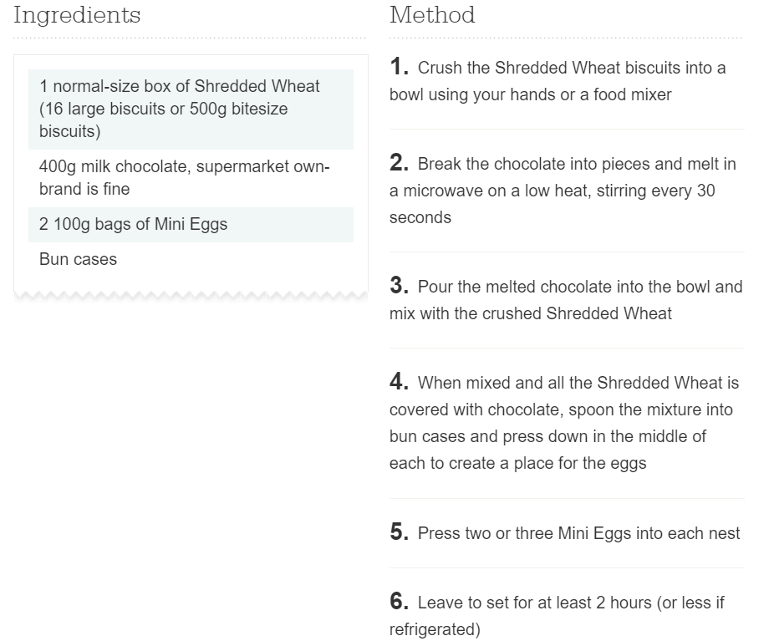

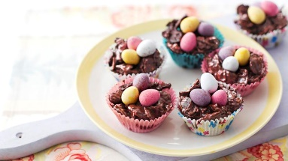

Papier Mache Easter Egg

You will need:

* PVA glue
* Water
* Paint brush
* Newspaper/tissue paper/ magazines
* Balloon/water balloon
* Paint
* Decorations

Instructions:

1. Make your papier mache glue by pouring PVA glue into a bowl and add a bit of water and mix until it is combined and slightly runny (make as much as you need or as little as you need).
2. Blow up your balloon to the size you want your egg, tie it up so it doesn’t deflate.
3. Get your choice of paper (Newspaper/tissue paper/ magazines) and rip it into small pieces.
4. Apply your glue mixture onto the balloon with the paintbrush and stick on the pieces of paper, keep applying glue over the top to make sure it sticks down.
5. Once you have done one layer, go back over and do another layer.
6. Stand it up on a cup to dry completely, this may take overnight.
7. Once dry, cut the balloon so the air is released, and it comes away from the papier mache.
8. Now, paint and decorate your egg.

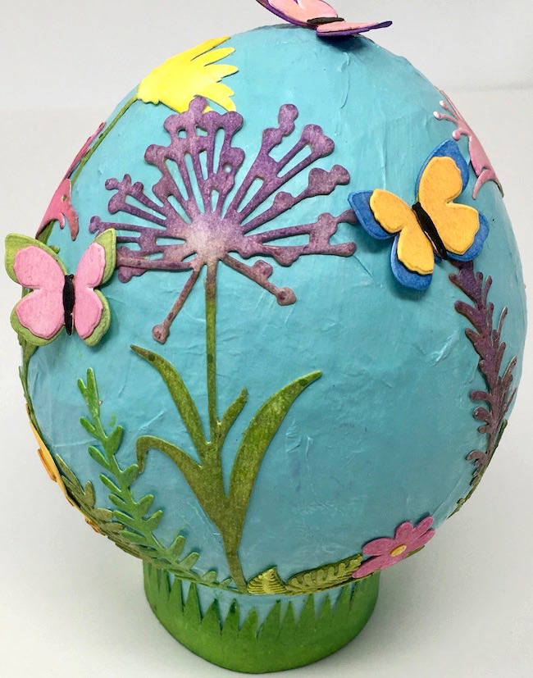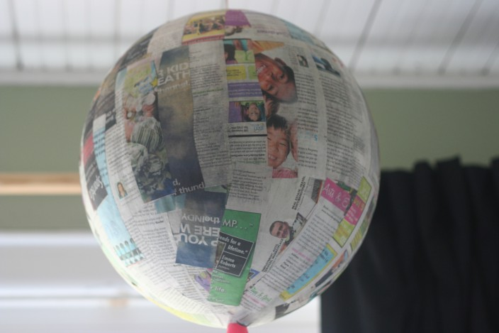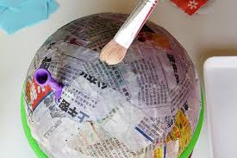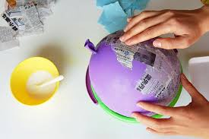

Easter Acrostic Poems

Can you write a poem just like mine?

Easter is coming

All children excited for chocolate eggs

Spring is here and the sun is out

Telling people about the Easter story

Eggs hatching into chicks

Rabbits racing through the grass